H Small Manual OS_KDHv2.1

SJ-H small food Freeze Dryer manual

CHAPTER 1

INTRODUCTION
Congratulations on your purchase of our Freeze Dryer System, which is designed for laboratory lyophilization procedures. The refrigerant used in the refrigeration system is CFC-free so it will not endanger the environment. The unit is easy to install and maintain. Proper care and maintenance of this equipment will result in many years of dependable service.
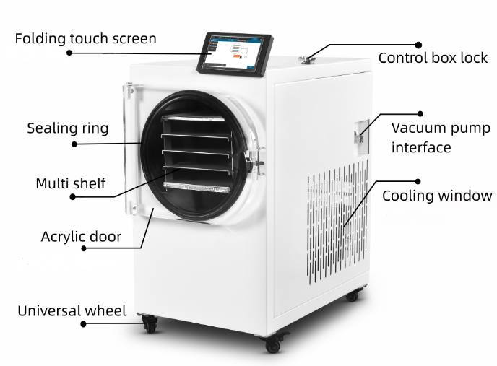

Freeze Dry Process
Freeze drying is an important process in sample preparation and for the preservation and storage of biologicals, pharmaceuticals and foods. Of the various methods of dehydration, freeze drying (lyophilization) is especially suitable for substances that are heat sensitive. Other than food processing (e.g., coffee, whole dinners), freeze drying has been extensively used in the development of pharmaceuticals (e.g., antibiotics) and preservation of biologicals (e.g., proteins, plasma, viruses and microorganisms). The nondestructive nature of this process has been demonstrated by the retention of viability in freeze dried viruses and microorganisms.
Freeze drying is a process whereby water or other solvent is removed from frozen materials by converting the frozen water directly into its vapor without the intermediate formation of liquid water. The basis for this sublimation process involves the absorption of heat by the frozen sample in order to vaporize the ice; the use of a vacuum pump to enhance the removal of water vapor from the surface of the sample; the transfer of water vapor to a collector; and the removal of heat by the collector in order to condense the water vapor. In essence, the freeze dry process is a balance between the heat absorbed by the sample to vaporize the ice and the heat removed from the collector to convert the water vapor into ice.

About This Manual
This manual is designed to help you learn how to install, use, and maintain your Freeze Dryer. Instructions for performing routine maintenance and making minor modifications to your Freeze Dryer are also included.
Note:As a company with technology as its core driving force, we have been always committed to technological innovation and optimization, ensuring that our software can be updated iteratively. Meanwhile, we are also making every effort to keep the instruction manuals provided along with the devices up to date. In view of the continuous upgrading of products and the ongoing updates of software, the actual product software information may change at any time. If there are slight differences between the instruction manual you received and the actual device at hand, but these differences generally won’t hinder your normal use, please rest assured that we will provide you with the updated instruction manual in a timely manner.

CHAPTER 2

PREREQUISITES
Before you install your Freeze Dryer, you need to prepare your site for installation. Carefully examine the location where you intend to install your Freeze Dryer. You must be certain that the area is level and of solid construction. An electrical source must be located near the installation site.

Electrical Requirements
The Freeze Dryer requires a dedicated electrical outlet. This outlet requires a (SJ-05H: 220v 10A,or 110V 20A;SJ-08H:220v 15A,or 110V 20A ) circuit breaker or fuse is required for models rated at 220V-240V (50 Hz). The power cord on 220-230V models are equipped with a plug on the power cord. It will be necessary to change a plug to match the available receptacle.

Unpacking Your Freeze Dryer
Carefully unpack your Freeze Dryer and inspect it for damage that may have occurred in transit. If your Freeze Dryer is damaged, notify the delivery carrier immediately and retain the entire shipment intact for inspection by the carrier.

Setting Up Your Freeze Dryer
After you verify receipt of the proper components, move your Freeze Dryer to the location where you want to install it. Then, follow the steps listed below.

Component Orientation
The refrigeration system in the freeze dryer sucks in air through the back of the cabinet and exhausts air out through the rear sides. A minimum of 2” should be allowed between the back and sides of the Freeze Dryer and the adjacent wall surface. Restriction of the airflow through the cabinet during operation could adversely affect performance.

Vacuum Pump Connection
A vacuum pump is required to operate your Freeze Dry System properly. The Freeze Dryer is equipped with a 25mm ID, heavy wall, vacuum hose for connecting the collector chamber to the vacuum pump.
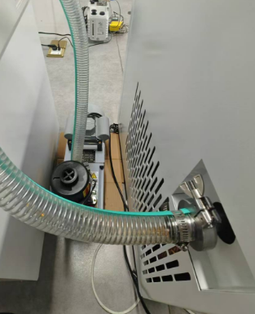
image.png

Make certain that the oil in the vacuum pump is at the proper level.
If vacuum pump is not inside the machine box, place the vacuum pump near the benchtop Freeze Dryer models, or place the vacuum pump on the floor.
Connect the vacuum pump power cord to the receptacle on the back of the cabinet labeled “vacuum pump” If the vacuum pump has an off/on switch, turn the switch on. The vacuum pump will be controlled by the Freeze Dryer. Connect the vacuum pump inlet port to the vacuum tube on the side of the cabinet with the vacuum hose and clamps provided. If necessary, cut the hose to proper length to allow for gentle bends without kinks.
Add the lubricating oil from the packaging box to the vacuum pump until the oil level reaches 2/3 of the observation glass，Regularly change the oil during use to ensure cleanliness inside the machine
The general replacement cycle is around 500 hours, depending on the actual usage situation.

Electrical Connection
Plug the power cord into the receptacle on the right side of the Freeze Dryer and plug the other end into a suitable power receptacle.
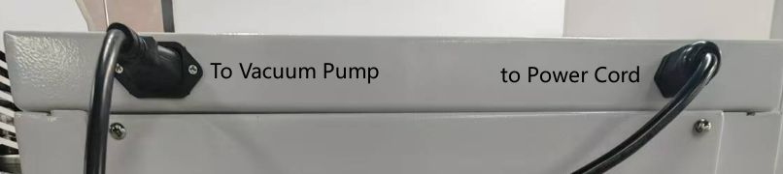
image.png
WARNING:It is necessary to confirm that the circuit can carry the electrical power of the machine to prevent the risk of fire！！！

CHAPTER 3 USING YOUR FREEZE DRYER
After your Freeze Dryer has been installed, you are ready to begin using your Freeze Dryer.
Put the food in to the freeze dryer.Check the gasket of the chamber whether there is water or ice in this area and make sure to clean it up thoroughly. Otherwise, it will affect the vacuum.
Close the door locker well,this is rotated and locked. Please refer to the following picture.
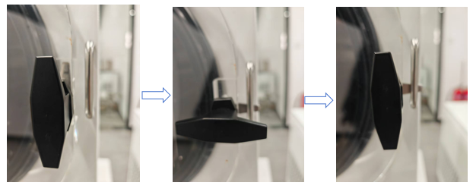

Freeze Dryer Controls and How to Run
Power one Freeze Dryer,you will see the Picture shows 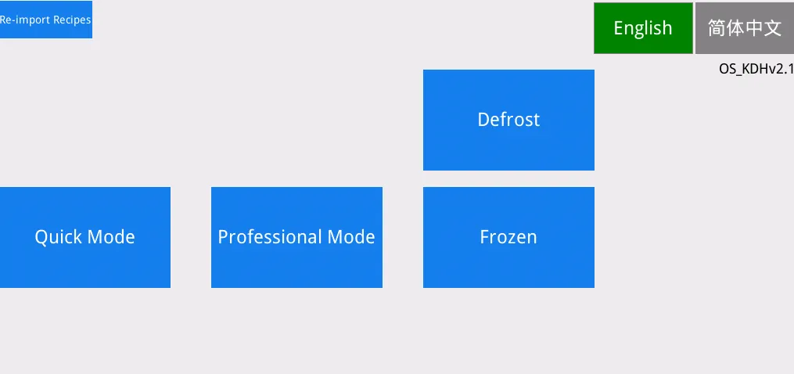
If your products is Non Fronzen .
Porduct will be Pre-frozen in the freeze dryer’s Chamber.
If your products is already Frozen,for example well frozen in a Refrige in to solid,then press ‘Frozen’.
Then Press ‘Quick Mode’ to start a freeze drying cycle.
Quick mode operation steps:
- Choose a Recipe for your product,the build-in Recipe is good for reference,if your product is not included here or the build-in recipe cannot freeze dryer well, then you can setup customer’s recipe,it will be mentioned in the below.(If these inbuilt Recipe) cannot drying your products well, please contact with us, we will try best to help you.
- After chose a Recipe,then you press ‘Load’ to load this recipe for running.
Note: you need to know not all products can be freeze dried.
After it,press ‘Start’ to to Run.
Current Recipe is the one which you loaded.
Note:Chek if the drain valve on the left side of the machine is closed and if the drying chamber door panel is properly closed.

Shut down and remove materials
When all down ,press ‘STOP’
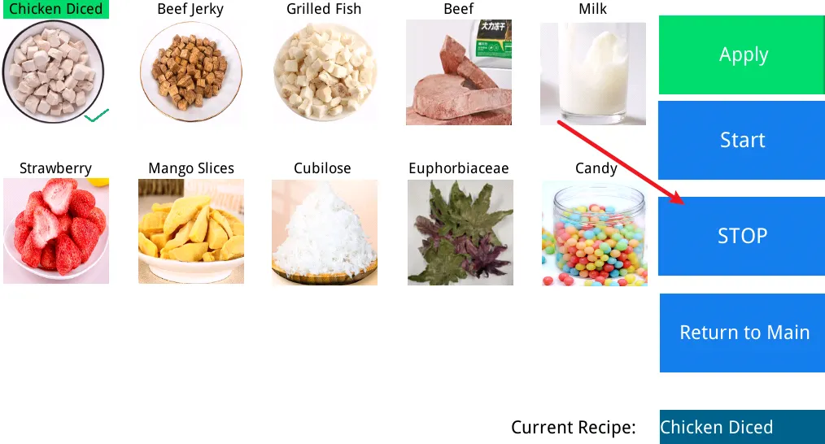
After the vacuum pump and compressor stop running.You can open the left drainage and exhaust valve and wait for the air pressure to balance before opening the cabin door to remove the freeze-dried food.

Defrost
Coonect a vessel to catch the flowing water when defrosting.
The defrosting time is about 60 minutes. After defrosting, you can turn off the machine switch, clean the machine, and wait for the next use.
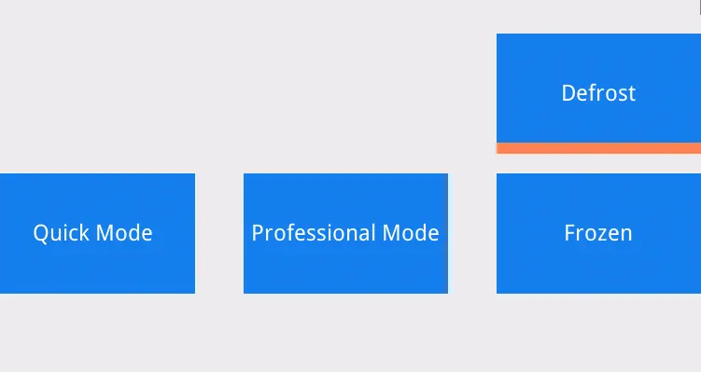

Professional mode operation steps:
If you are well -know about the freeze dryer,profession mode can give you more options for Running a freeze drying cycle.
From the main interface,press ‘Professional Mode’ to start .
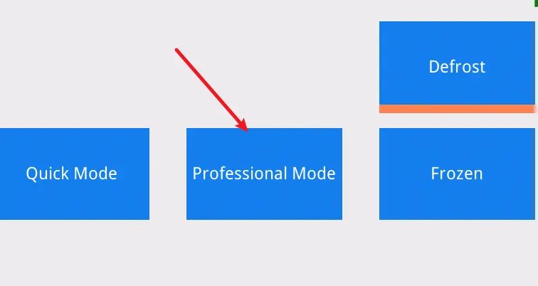
Buttons introduction:
- Refrige:start compressor to Run ,then condenser temperature will drop.During this stage(without vacuum pump is running) ,loaded products/food can be frozen.
- Vacuum: this button can start the vacuum pump,but it requires refrige is on and condenser temperature ≤ -25C,otherwise it cannot be turned on.
- Auto start : when you loaded a recipe(from recipe manage or from the quick mode already loaded or last time’s recipe.) Press this button to start a cycle automaticly.When auto is running, then user can stop autoly,otherwise user should turn off by pressing refrige and vacuum buttons.

CHAPTER 4 MAINTAINING YOUR FREEZE DRYER
Under normal operation, the Freeze Dryer requires minimum maintenance. The following maintenance schedule is recommended:
As needed:
1. Clean up all spills; remove liquids from the chamber.
2. Clean lid and gasket using soft cloth, sponge or chamois and a mild, non-abrasive soap or detergent.
3. Check oil level of the vacuum pump. It should be over the middle line of oil mirror. If the oil level is lower, add oil to proper level.
4. If oil shows cloudiness, particles or discoloration, drain the pump and replace with fresh oil.
5. Utilization of acids requires immediate cleaning and neutralization after a run or physical damage to the collector chamber and collector coil will result.
6. Check the collection condenser for condensed or frozen solvents and dispose them appropriately. Completely empty the collector chamber before the next run or before starting the vacuum pump.
7. If chamber or manifold valves leak or stems become difficult to turn, pull the stem out of the rubber valve body and apply a thin coat of vacuum grease to the stem. Reinsert the stem into the valve body.

CHAPTER 5 IOT Remote Control and Camera Monitor
If the IoT (Internet of Things) remote function is selected as an option, and a camera is also added as an optional component, users can then connect to the camera, and the video images will be transmitted to the screen via the remote control system.
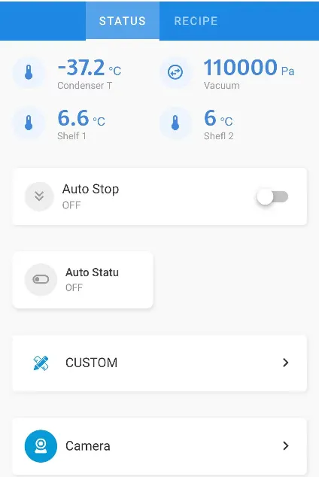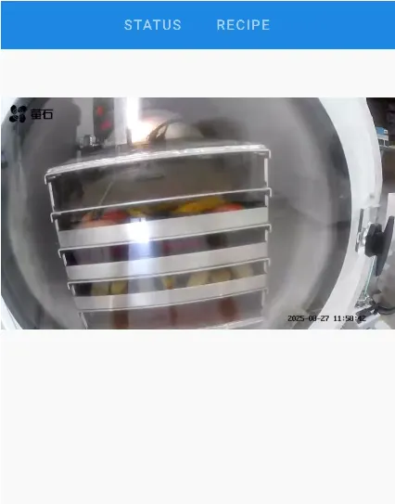

How to Setup a Custom Recipe?
Active the profession Mode :press ‘setting’,the press ‘Professional Mode’ to active the profession mode
Return back to ‘Return to Main’ ,then press the ‘Professional Start’
2.1 In the Professional Mode press the ‘Operation Interface’,then it will show the menu list,press the ‘Recipe Manage’

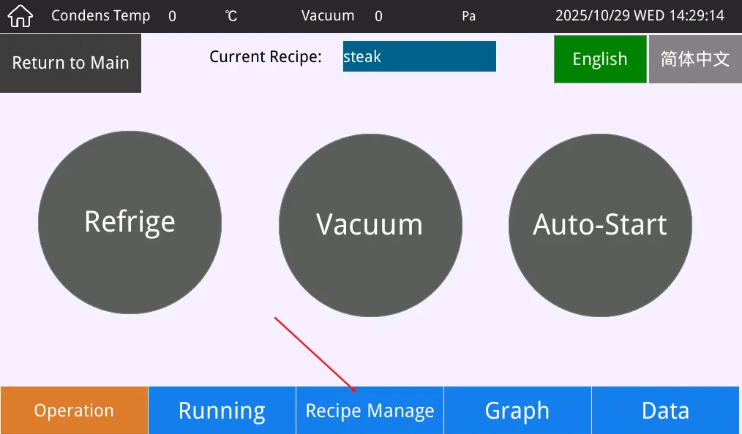
2.2 in this page,press ‘choose’ of a recipe list. Then press the ‘change’ to change the recipe to your’s.
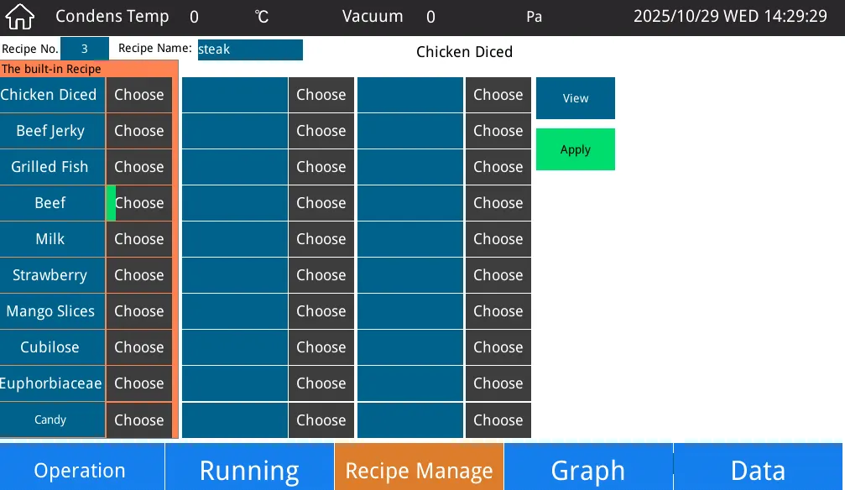
Don’t forget to input your recipe name.
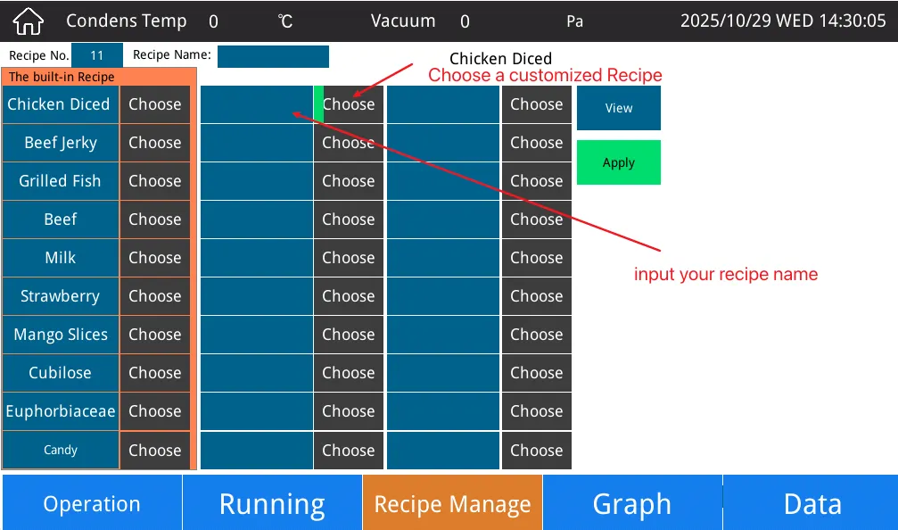
2.3 how to set a recipe
when ‘choose’ a recipe and input your recipe name, then press “View” to start set a recipe(password is ‘555555’).
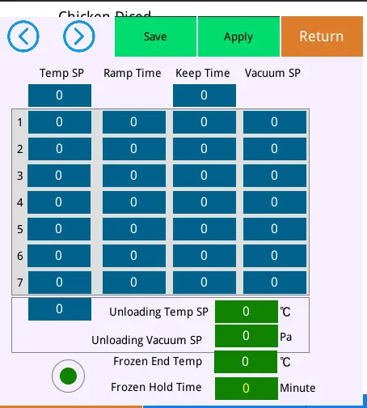
2.3.1 Freezing tempe: you can set a low temp for prefreezing food, it will cool the chamber as low as possible.
2.3.1 Freezing Hold time: 300min,it will run at this step for 300min. But if you active the ‘Frozen end tem and Frozen Hold time’
then when shelves temperature reach to this setpoint for example -30C,then start for timming,until keep it as 60min,then system will go to dry step automatic.
If freezing hold time also finished, it also will go to dry step.
2.3.2 other steps for drying. Don’t forget set the vacuum.
This vacuum is not control the vacuum pressure.This function is when vacuum lower than setpoint,the sheft heating is availabe, otherwise it will not heat.
2.3.3 unloading temp sp/vacuum: this is the last step of drying, the food will keep drying at this step until user take food out.Don’t forget set the vacuum for it,otherwise it will not keep heating or hold temperature.
2.4 press ‘’save’ to save this recipe.
2.5 press Apply to load this recipe to run or pre-load,which is easier for run.
Why the door left side is not fixed?
Answer:
The left side of the door is fixed with spring-loaded screws. The elasticity of the springs is used to adjust the tightness of the door. Therefore, the left side of the door can move back and forth within a certain range.
The handle for locking the door is a cam lock. To engage the lock, you need to rotate it an additional 90 degrees to the right, as shown in the figure below.

New Software Keep Updating
The above covers the basic operation of the H-series freeze dryers. We will continue to provide software updates; if you need to upgrade, you can choose from the following versions.
How to update:
- Download the HMI file in zip, upzip it and put into a TF card(Format FAT32,its better not ≥32G).
- Place the "private" folder extracted (from the compressed file) in the root directory. If this fails, open the folder to check if there are any subdirectories inside.
- Insert the TF card into the freeze dryer’s HMI’s.Then it will show updating,after it, remove the card .

